An Internship Report
On
DATA ANALYTICS
Submitted To
School of Computer Science and Engineering IILM University, Greater Noida, U.P.
In partial fulfilment of the requirement of degree of
B.Tech CSE

By
Roll Number of Student: 25SCS1003005200
Name of Student: ISHIKA AGARWAL
Batch: 2024–2028

CANDIDATE'S DECLARATION
I, ISHIKA AGARWAL, Roll No. 25SCS1003005200, do hereby declare that the internship report titled “DATA ANALYTICS” has been completed by me to fulfil the requirement for the award of the degree of Bachelor of Technology in Computer Science and Engineering. All the references have been quoted and I have not taken as such any material from any other source. I affirm that this report is my own work and has not been submitted to any other institute for any degree/diploma requirement, and I shall be solely responsible for any kind of copyright violation in this regard.
Signature: ______________________
Student Name: Ishika Agarwal
Roll No.: 25SCS1003005200
ACKNOWLEDGEMENT
I am using this opportunity to express my gratitude to everyone who supported me throughout the Internship Program on Data Analytics. I am thankful for their aspiring guidance, invaluably constructive criticism and friendly advice during this work. I am sincerely grateful to them for sharing their truthful and illuminating views on a number of issues related to this work.
I would like to thank the faculty of the School of Computer Science and Engineering, IILM University, Greater Noida, for their continuous support and encouragement, and my mentors at Gneiss Industries Pvt Ltd for providing me the opportunity to work on real-world data analytics problems and for their valuable guidance throughout the internship.
I express my gratitude to my parents for their blessings.
Signature: ______________________
Student Name: ISHIKA AGARWAL
Roll No.: 25SCS1003005200

INTERNSHIP COMPLETION CERTIFICATE
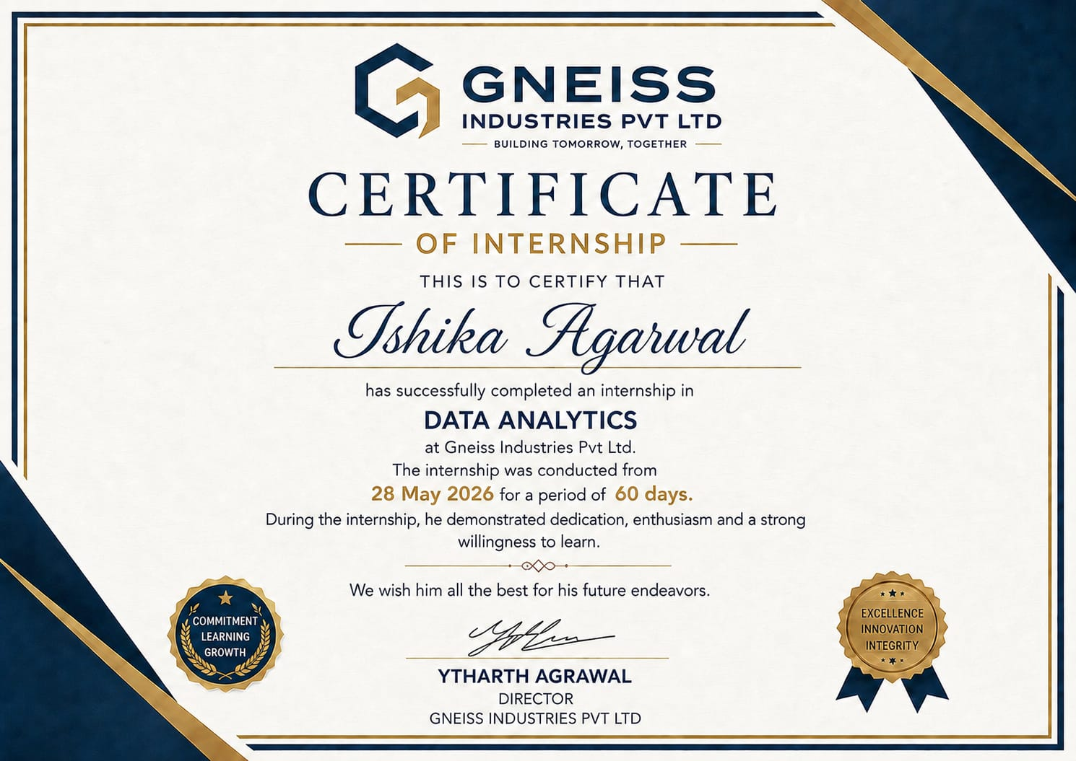
Certificate of Internship – Data Analytics, Gneiss Industries Pvt Ltd
Awarded to ISHIKA AGARWAL | Internship Duration: 28 May 2026 – 60 days
TABLE OF CONTENTS
Cover Page ......................................................................................................................... —
1. Candidate's Declaration ................................................................................................... i
2. Acknowledgment ............................................................................................................. ii
3. Internship Completion Certificate .................................................................................. iii
4. Project Description ......................................................................................................... 1
4.1 Introduction ............................................................................................................. 1
4.2 Organization Profile ................................................................................................ 2
4.3 Problem Statement .................................................................................................. 3
4.4 Project Objectives ................................................................................................... 4
4.5 Scope of the Project 5
4.6 Technologies and Tools Used 6
4.7 System Architecture 7
4.8 Methodology 8

4.9 Expected Outcomes .............................................................................................. 10
4.10 Certificates of Completion / Mail Proof ............................................................. 11
5. Bibliography/References ............................................................................................... 12

4.1 Introduction
This report presents the work undertaken during my internship in the domain of Data Analytics. Data Analytics is the process of examining raw data with the objective of drawing meaningful conclusions, identifying patterns, and supporting evidence-based decision making. In today's datadriven world, organisations across industries rely heavily on analytics to understand customer behaviour, optimise operations, forecast trends, and gain a competitive advantage.
During the internship, I was exposed to the complete lifecycle of a data analytics project, starting from data collection and cleaning, through exploratory data analysis and visualization, to building predictive models and communicating insights to stakeholders. This report documents the organisation in which the internship was carried out, the problem addressed, the objectives and scope of the project, the tools and technologies used, the system architecture, the methodology followed, and the outcomes achieved. As part of the internship, I also completed an independent Data Analytics Assessment through LearnTube.ai (backed by Google for Startups), the results of which are summarised in Section 4.10 and validate the practical skills developed during this project.

4.2 Organization Profile
The internship was carried out at Gneiss Industries Pvt Ltd, a private limited company headquartered in Noida, Uttar Pradesh, operating under the tagline “Building Tomorrow, Together.” The organisation is led by its Director, Mr. Ytharth Agrawal, and has built its internship and training programmes around three core commitments – Commitment, Learning, and Growth – alongside the broader organisational values of Excellence, Innovation, and Integrity.
Gneiss Industries Pvt Ltd works on projects that involve converting raw, unstructured business data into actionable insights through statistical analysis, data visualisation, and analytics-driven reporting. As an intern with the organisation, I was given the opportunity to work under the guidance of experienced mentors, participate in structured learning modules, and apply data analytics concepts to a real project brief. The organisation's emphasis on mentorship and hands-on learning provided a practical, industry-oriented environment in which to develop skills in data cleaning, exploratory analysis, and dashboard/report creation.
The internship was conducted over a period of 60 days, commencing 28 May 2026, during which I was evaluated on dedication, enthusiasm, and willingness to learn – the qualities the organisation highlights as central to its internship programme.

4.3 Problem Statement
Organisations today generate massive volumes of data through their day-to-day operations, but a large portion of this data remains under-utilised due to the lack of proper analysis frameworks. The problem addressed during this internship was to design and implement a data analytics workflow that could clean, process, and analyse a real-world dataset in order to uncover trends, detect anomalies, and support decision making through clear visualisations and predictive insights.

4.4 Project Objectives
The key objectives of the internship project were as follows:
- To collect and consolidate raw data from multiple sources into a single, structured dataset.
- To clean and pre-process the data by handling missing values, duplicates, and inconsistencies.
- To perform exploratory data analysis (EDA) to identify patterns, correlations, and outliers.
- To build interactive dashboards and visualisations for effective communication of insights.
- To apply basic statistical and machine learning techniques to generate predictive insights.
- To document findings and present actionable recommendations to stakeholders.

4.5 Scope of the Project
The scope of the project was limited to analysing a defined dataset relevant to the organisation's business domain over a fixed internship duration. The project covered data cleaning, exploratory analysis, visualization, and basic predictive modelling. It did not extend to full-scale deployment of models into a live production environment, though recommendations for future scalability and automation have been discussed in the concluding sections of this report.

4.6 Technologies and Tools Used
The following technologies and tools were used during the course of the internship:
- Programming Language: Python (Pandas, NumPy, Matplotlib, Seaborn, Scikit-learn)
- Query Language: SQL for data extraction and aggregation
- Visualization Tools: Power BI / Tableau for building interactive dashboards
- Development Environment: Jupyter Notebook and Visual Studio Code
- Version Control: Git and GitHub for collaborative development
- Spreadsheet Tools: Microsoft Excel for preliminary data checks and reporting

4.7 System Architecture
The system architecture followed a standard analytics pipeline consisting of four major layers: (1) the Data Source layer, where raw data was collected from files, databases, or APIs; (2) the Data Processing layer, where data cleaning, transformation, and feature engineering were performed using Python and SQL; (3) the Analysis layer, where statistical analysis and machine learning models were applied to the processed data; and (4) the Presentation layer, where results were visualised through dashboards and reports for end users and stakeholders.
Fig. 4.1: Data flows from raw sources through the cleaning and transformation stage, into the analysis and modelling stage, and finally into the visualization and reporting layer that is consumed by business stakeholders.

4.8 Methodology
The project followed a structured methodology comprising the following stages:
- Data Collection: Gathering raw data from the organisation's databases and external sources.
- Data Cleaning: Handling missing values, removing duplicates, and correcting inconsistent formats.
- Exploratory Data Analysis (EDA): Using descriptive statistics and visualisations to understand data distribution and relationships between variables.
- Feature Engineering: Creating new relevant variables to improve the quality of analysis.
- Model Building: Applying appropriate statistical or machine learning techniques (such as regression or classification) to derive predictive insights.
- Evaluation: Assessing model performance using suitable metrics such as accuracy, precision, and RMSE.
- Reporting: Presenting the findings through dashboards, charts, and a summary report for stakeholders.

4.9 Expected Outcomes
By the end of the internship, the project was expected to deliver the following outcomes:
- A clean, well-structured dataset ready for analysis.
- A set of clear visualisations highlighting key trends and patterns in the data.
- An interactive dashboard enabling stakeholders to explore the data independently.
- A predictive model providing actionable insights to support business decisions.
- A comprehensive report summarising the methodology, findings, and recommendations.

4.10 Certificates of Completion and Other Communication / Mail Proof
As proof of the internship undertaken, I was awarded the Certificate of Internship by Gneiss Industries Pvt Ltd, reproduced in Section 3 (page iii) of this report, confirming successful completion of a 60-day internship in Data Analytics commencing 28 May 2026, signed by Mr.
Ytharth Agrawal, Director, Gneiss Industries Pvt Ltd.
In addition, as independent validation of the skills developed during the internship, I completed the LearnTube.ai Data Analytics Assessment (backed by Google for Startups). A summary of the assessment performance is presented below.

Assessment Performance Summary
- Overall Score: 100% (10.0 / 10 correct answers), placing the candidate in the elite 5% of Data Analytics professionals assessed.
- Weekly Rank: 39 out of 154 participants.
- Global Rank: 39 out of 74,307 participants.
- Difficulty Coverage: Questions spanned Easy, Medium, and Hard levels, covering the goals of data analytics, growth and churn metrics, exploratory data analysis, churn prediction modelling, and business forecasting under external/regional factors.
- Identified Strong Areas: Excellent problem-solving, strategic perspective, and effective communication of analytical findings.
- Certificate ID: DJA-B-1-2999033-0, issued August 30, 2026 by LearnTube.ai cofounders Shronit Ladhani and Gargi Ruparelia.
This certification, together with the hands-on project work described in Sections 4.1 to 4.9, demonstrates both the theoretical understanding and applied competency gained in data analytics during the internship period.
CHAPTER 5: BIBLIOGRAPHY / REFERENCES
- Wes McKinney, “Python for Data Analysis,” O’Reilly Media, 3rd Edition, 2022.
- Jiawei Han, Micheline Kamber, Jian Pei, “Data Mining: Concepts and Techniques,” Morgan Kaufmann, 3rd Edition.
- Pandas Documentation, https://pandas.pydata.org/docs/, accessed during internship period.
- Scikit-learn Documentation, https://scikit-learn.org/stable/, accessed during internship period.
- Microsoft Power BI Documentation, https://learn.microsoft.com/power-bi/, accessed during internship period.
- GeeksforGeeks, “Introduction to Data Analytics,” https://www.geeksforgeeks.org/, accessed during internship period.
- Internal project documentation and training material provided by Gneiss Industries Pvt Ltd.
- LearnTube.ai, “Data Analytics Assessment – Certificate of Completion,” issued August 30, 2026.

